Thera Puppets
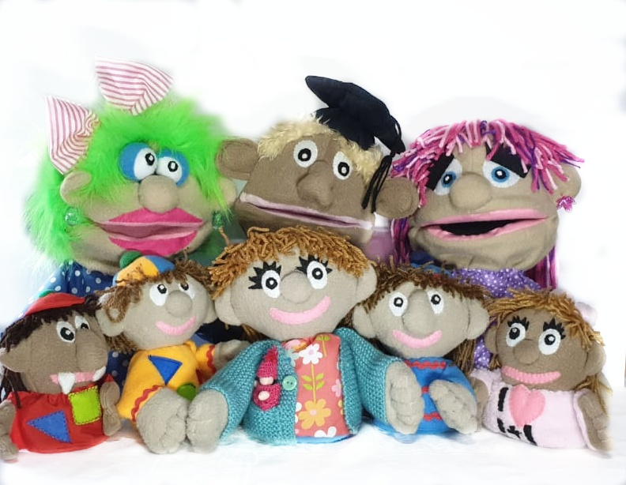
Catalogue
Large puppets:
Information processing metacognitive skills
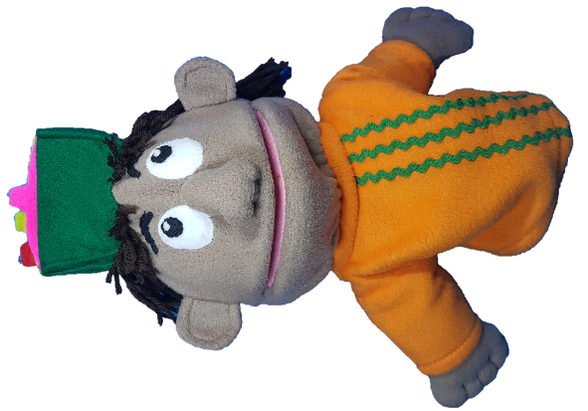

Large puppet

Math anxiety
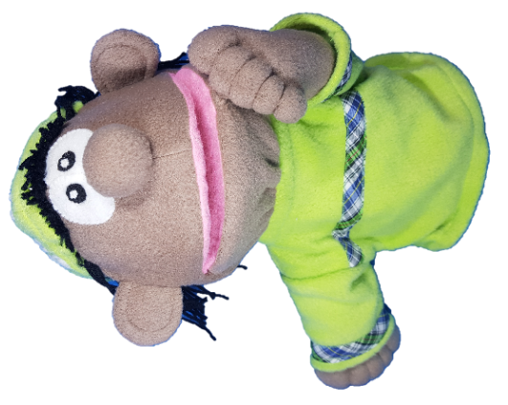

Large puppet

Attitude towards Maths

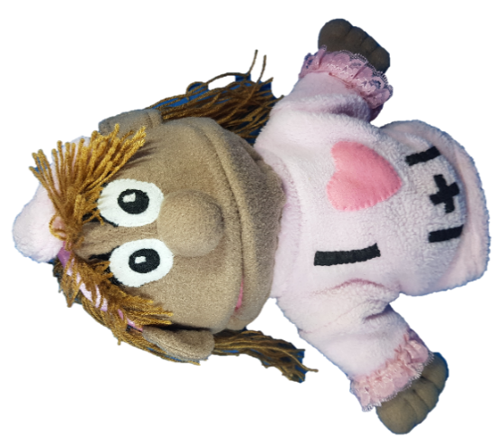
Large puppet

Study habits
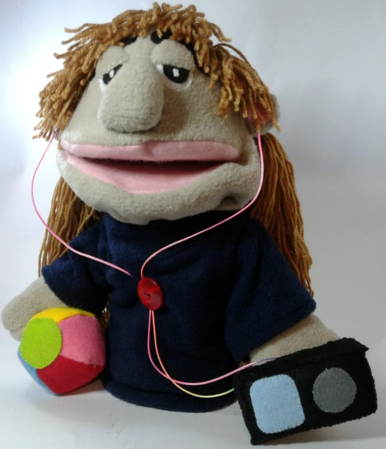

Large puppet

Thinking brain

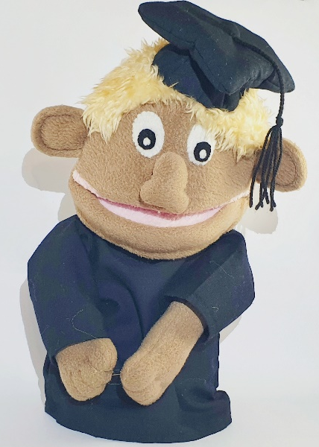

Large puppet

Feeling brain.

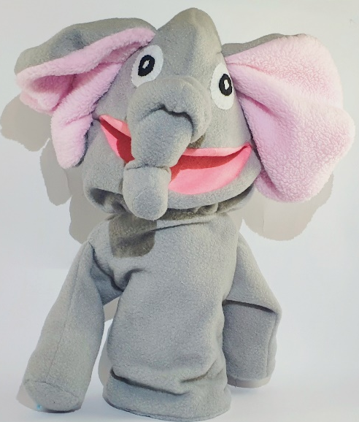
Large puppet

Primitive brain

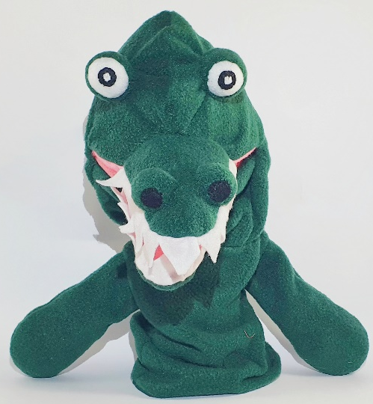
Large puppet

Whartel
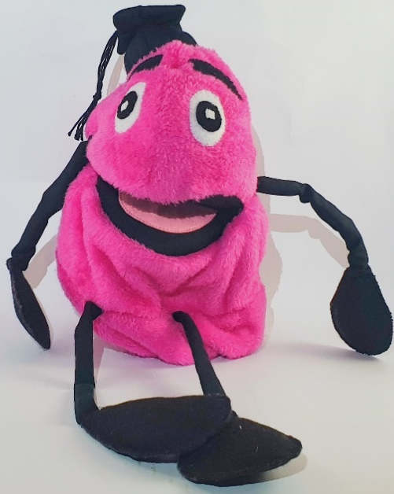

Large puppet

Whoblin

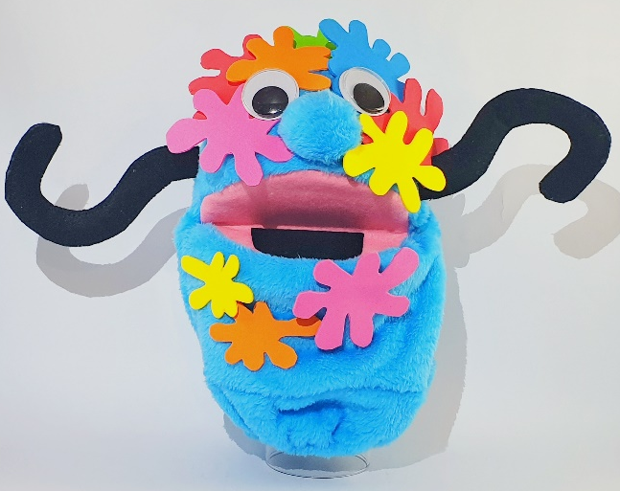
Large puppet

Small puppets:
Information processing metacognitive skills.
Small puppet

Math anxiety.
Small puppet

Attitude towards Maths.

Small puppet

Study habits.

Small puppet

Thinking brain

Small puppet

Primitive brain

Small puppet

Feeling brain.

Small puppet

Whartel
Small

Whoblin
Small

Whole set

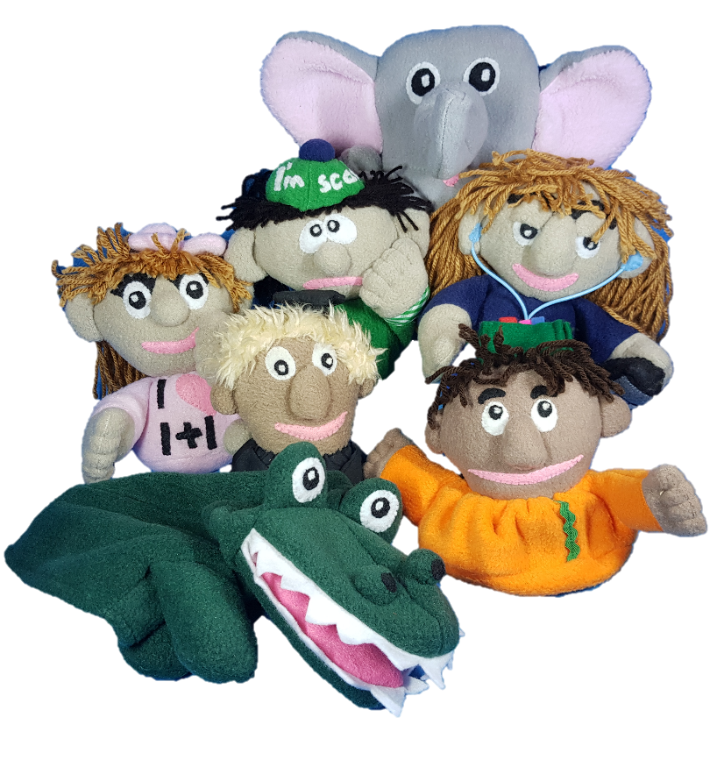
Whole set includes all puppets under Small puppets.
Comes with a denim carrier bag.

XX girl & XY boy dolls

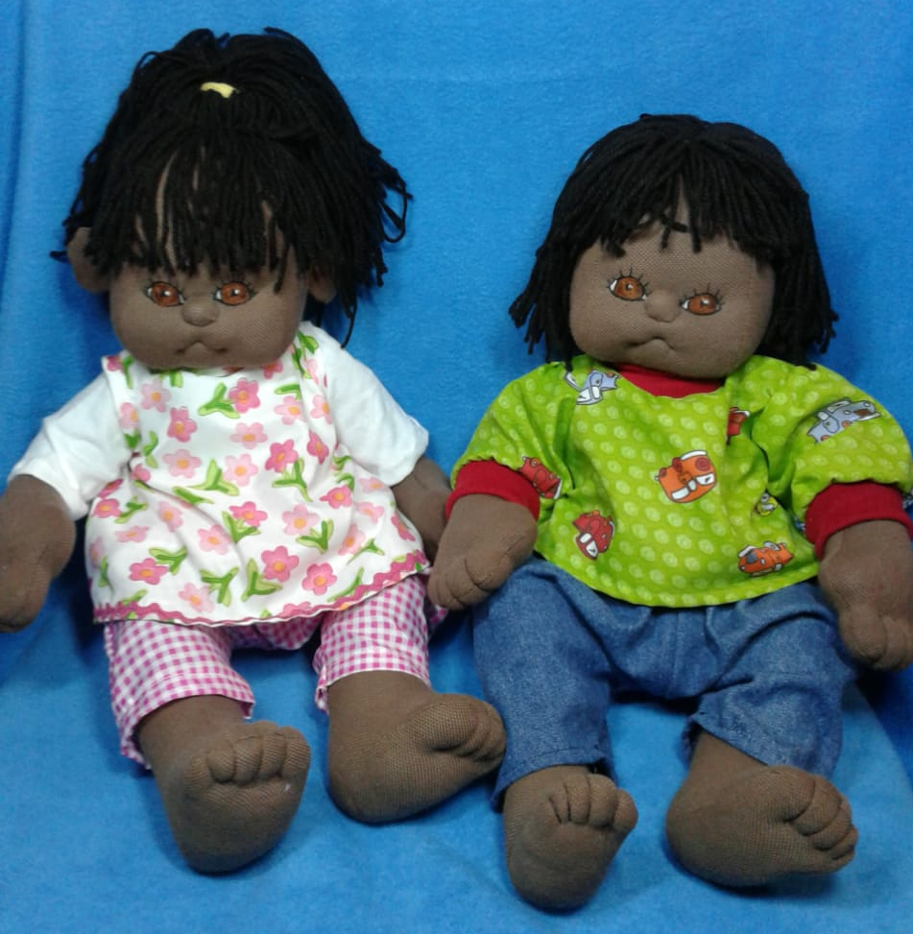

Anatomically correct dolls.

Personalize a puppet
Tell us your story, and what you would like your puppet to represent and together we will design a unique puppet just for you. This can include child’s name, or school’s name or any character’s name. Colour scheme and logos as per clients choice.
Send us an email to describe what you want your puppet to look like.
Examples.
Ino” the innovation puppet
Use the included accessories to change the puppet into either a girl or a boy.
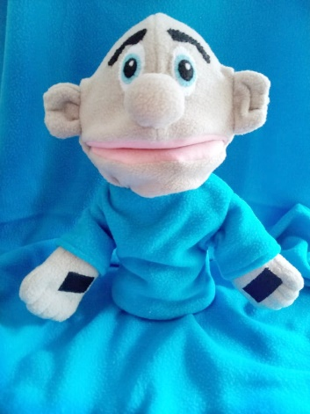

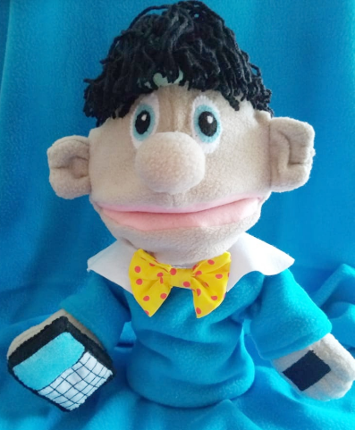
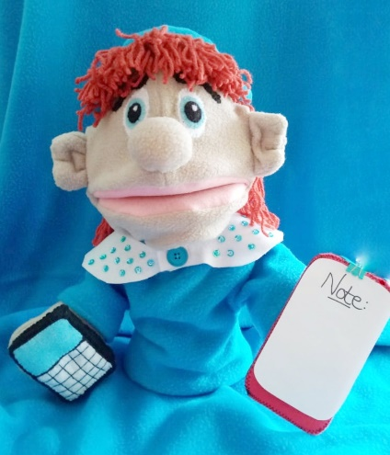

Personalise the puppet with special details for example a London or African themed puppet
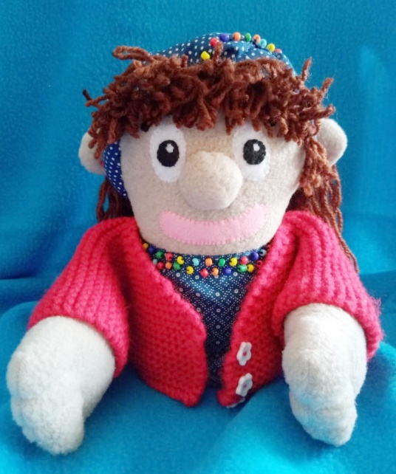
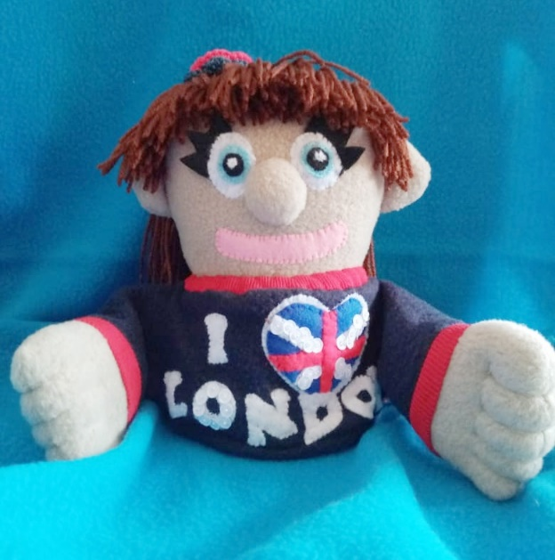

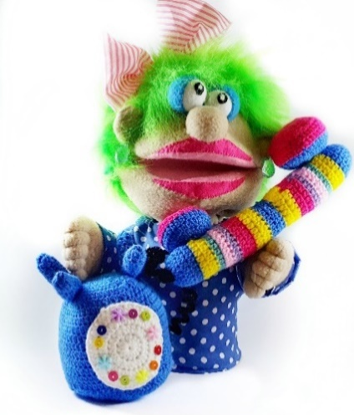
Or some funky details like green hair
Other examples
